RICKMANSWORTH WATERWAYS TRUST EDUCATION CENTRE
OPENING UP AND CLOSING DOWN PROCEEDURE.
Introduction.
This document is intended for use by persons opening and closing the education centre when no RWT trained personnel are present. Please phone 07875 393703 if you have any difficulties.
Pictures have been added to the document for ease of reference.
OPENING.
- The key provided is for the main entrance to the building adjacent to and above the black steps. There is also a grey ‘fob’ with the key which both cancels and sets the building alarm.
- Place the key in the lock and turn to the right to unlock.
- The door open inwards and a beeping sound from the will be heard.
- The alarm panel is situated adjacent to the right of the main door (as you enter)
- To cancel the alarm, hold the fob up to the alarm panel in front of the ((( ))) markings on the right hand side of the panel.
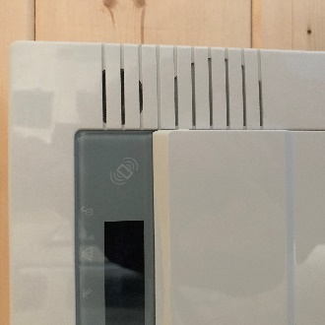
- The lights for the building are turned on from the light switches again to the left of the main doors. They are marked ‘Lobby’ and ‘Main Hall’
RF = roof lights
UP = uplighters.
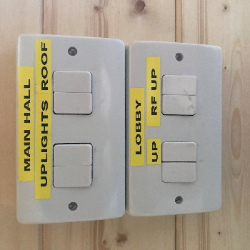
- Move the blinds back and forth as necessary by using the clear wand attached to the top centre of the blind mechanism. Please turn the blinds to fully open before drawing them back into position.
Leave the blinds in the closed position, fully turned either to left or right.
- The ‘Velux’ windows and blinds are operated from a panel attached to the wall by the electric screen. All windows and blinds can be operated from this panel either individually or as a whole.
- Tap the ‘House’ symbol on the bottom right of the panel. This will wake up the Controller.
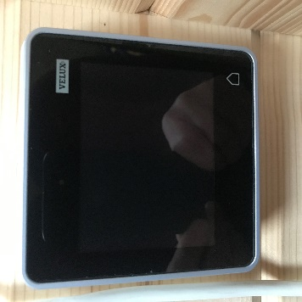
- Swipe either left or right to find the selection for the windows and blinds you require. For instance, to open all the blinds swipe to ‘All Blinds’ then tap the open symbol on the bottom left of the controller. The blinds will retract all the way or you can stop them by tapping on the word ‘Stop’ Individual blinds can be open and closed as required. A diagram of the numbering system for each window/blind is next to the controller.
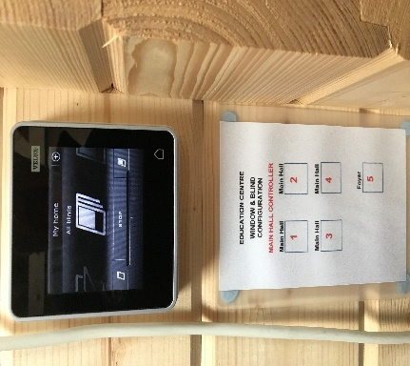

- FIRE DOORS
The main door to the building, hall door number 8 (first door on the left as you enter the Hall) and the outside door in the office are the recognised fire doors.
When the building is occupied the main door and main hall door number 8 MUST be left unobstructed. ‘Break Glass’ holders containing the relevant keys for the doors are situated adjacent to the various doors in the Hall & Office.

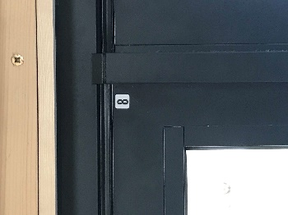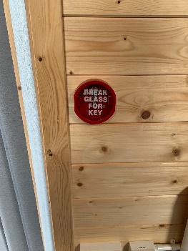

- The heating will be turned on ready for your visit and will turn itself off after you leave. If the hall gets too warm then use the main power switch adjacent to each heater to turn them off. Please do not attempt to change the heat settings on the front panel control.
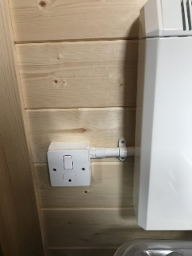

- The projector, speakers and screen are fixed in position and must not be moved. A remote control is used to turn on the projector and speakers and instruction will be given if use is required. The use of the projector requires a HDMI port on a computer.

- CLOSING UP THE BUILDING.
When leaving the building,
- Close all windows and blinds using the Hall Controller
- Turn all lights off
- Close all internal doors
- Set alarm by holding the grey key fob against the alarm panel ((( ))) markings
- Close main door gently lifting the handle up to set the lock.
- Lock the door and post the key into the post box on the left of the doors.

- ACCESS TO THE DECKING & SEATING AREA AT REAR OF THE HALL
- Key Number 8 which is hanging up adjacent to the alarm panel opens the fire door in the Hall providing access to the decking and seating area.
- If used during any hire please ensure the door is locked prior to leaving the building.

